## 

OWL IIS DEPLOYMENT DOCUMENT

Team 4

## OWLWebsite:

These steps were done on Windows 7 64 bit.

1. Install IIS through control panel\programs and features
2. In IIS Manager (available in control panel\administrative tools) Create a new website, and point the path to the OWLWebsite location (c:\OWL\swegroup-4\OWLWebsite\). You should be able to set the url to localhost:32297
3. Go to C:\windows\system32\inetsrv\config
4. update applicationHost.config - change handlers to allow and modules to allow. See below:

"To correct error I changed the following values located in the applicationHost.config file located in Windows\system32\inetsrv.w

Change all of the following values located in section <configSections> --> <sectionGroup name="system.webServer">

<div mce_keep="true"><section name="handlers" overrideModeDefault="Deny" /> change this value from "Deny" to "Allow"</div>

<div mce_keep="true"><section name="modules" allowDefinition="MachineToApplication" overrideModeDefault="Deny" /> change this value from "Deny" to "Allow"</div>"

5) Go to C:\Windows\Microsoft.NET\Framework64\v4.0.30319 and run aspnet_regiis -i to re-register ASP.net.

6) Go to Control Panel > Application Pool > Make sure that the .Net Framework version that you are running OWLWebsite is v4.0 instead of something else.

## FrontEnd:

1. Add in the link to location for the owl-front. Have it point to localhost.

## Database:

1. Add User account to Windows: OWLWebsite Password: "OWLWebsite"
2. In SQL Express, under OWL, got to security and select "New" and then "User"
3. Set UserType to Windows User
4. Add in "OWLWebsite" as the user and set the default schema to 'dbo.'
5. Go to Membership for the user and select db_datareader and db_datawriter.
6. In IIS, go to application pools. Select OWLWebsite and "advanced settings" under edit application pool in the right hand pane.

## To Test:

1. Do a refresh of the IIS website.
2. Go to localhost/owl.html
3. Select an entry and run the query
4. You should see the result returned.

## HTTPS Instructions

1. With the working setup, go to site bindings for OWLWebsite and OWL. Update to match the below:

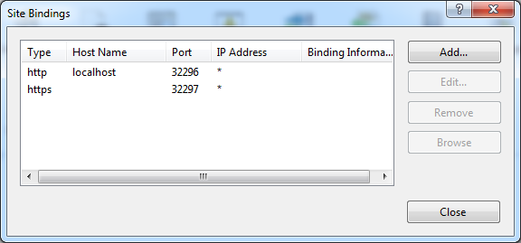

2) Update SSL settings to match the below:

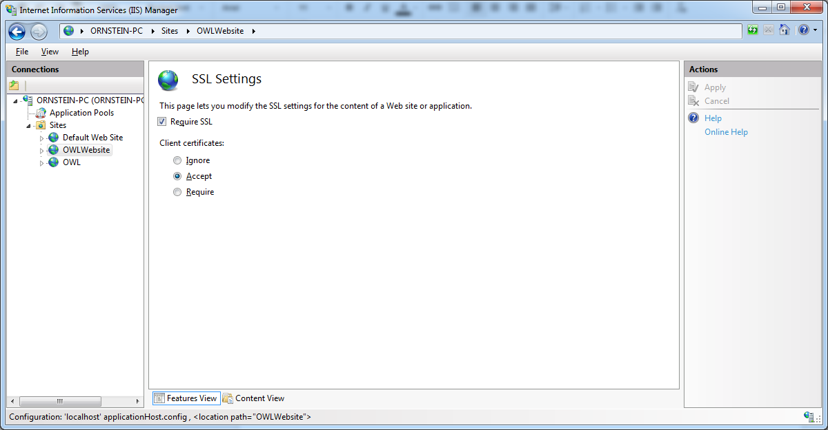

You will also be prompted to create a certificate. Just use the default ASPNET certificate.

To do connections, it is <https://localhost:32297> and <https://localhost/owl.html>

## Installing ASP

ASP is necessary for the Contact Us and Report a Bug pages.

1. Go to control panel, programs and features, and select Turn WIndows Features on or off on the left hand side
2. Navigate to install ASP (shown below)

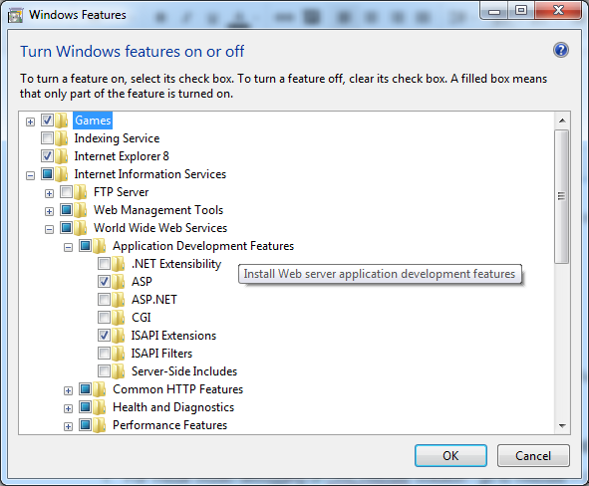

## How to Adjust the Port of Visual Studio/OWL Front-end Website

1. For Visual Studio debugging of OWLWebsite Solution - go to Website > Options > change the address to localhost:32297.
2. For viewing the front-end website - Go to C:\swe-group4\owl-front\src\ClientCommunicationModule.js
   1. Make sure that this line is exactly written as below:
      1. var serverAddress = "https://localhost:32297";

## Running Website on Browser Instructions

1. Make sure that you enable “unsafe scripts” in Google Chrome or click on the lock symbol in Firefox’s web address box so that you can make exception for our site.
   1. You do this, because our site has unsafe parts to them since we do not a certificate from a third party.